How to Install Rstudio

Open a web browser

Go to <https://rstudio.com/products/rstudio/download/>

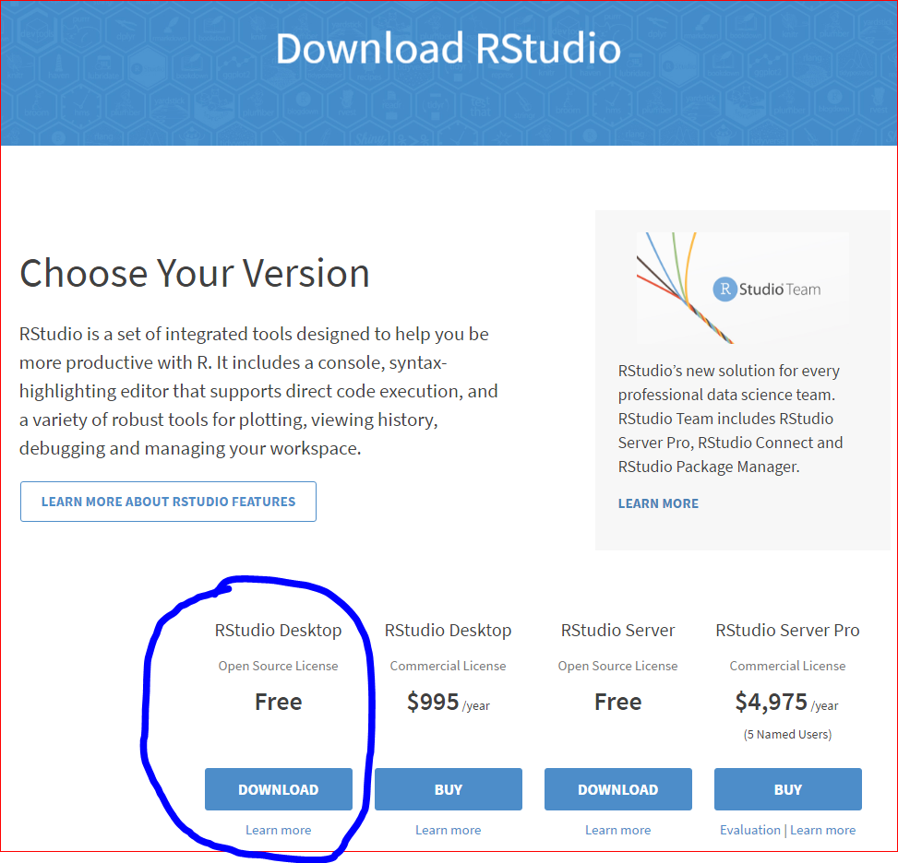

Click to download the free RStudio Desktop version

This will take you to this page of choices

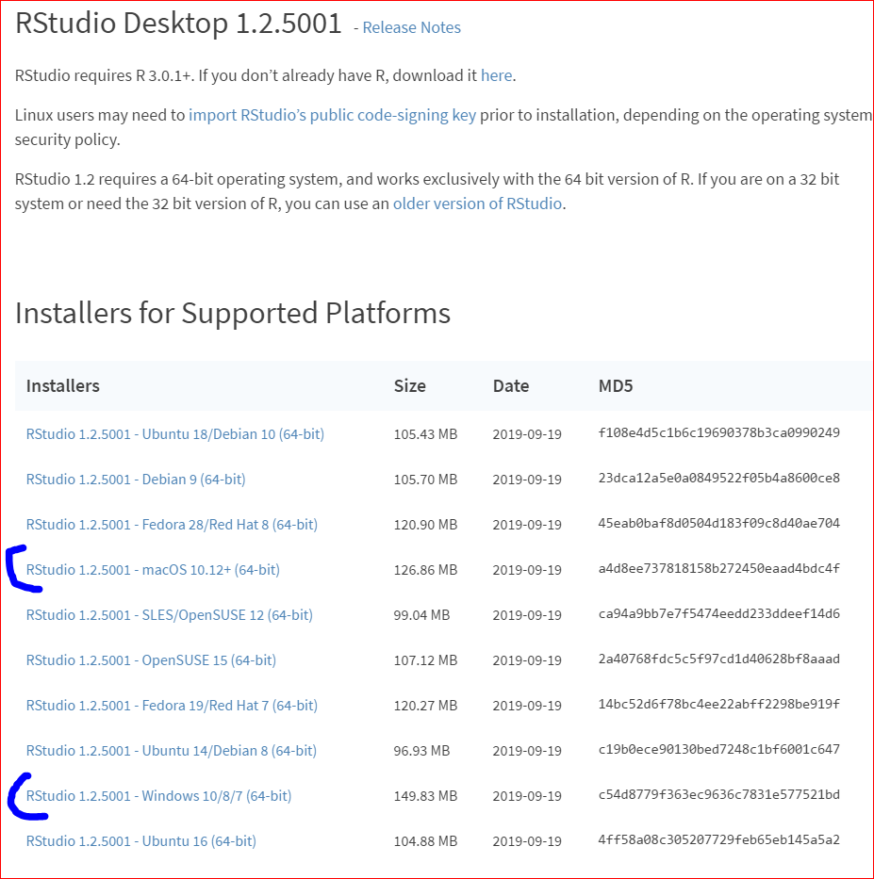

Most folks will want the MacOS or Windows version.

Pick the right one for you and click on it

This will download to a tab at the bottom left of your browser window in Windows 10.

Click on the downloaded file to open and run it.

In general, use the default install.

Finish to close setup.